Time Resolved Absorption Spectroscopy Manual

Aim : To examine how fast the excited triplet state ³ZnTPP* state is depopulated after being populated by a pump laser pulse and compare this relaxation time for three different pump pulse widths.

Theory : This technique studies the kinetic details of chemical processes down to pico- or femtoseconds, enabling the detection of intermediate states of photochemical reactions and electron transfer processes. The experiment is to calculate the transient absorption (denoted as TA or ΔA) of a molecular system via a transmission measurement. From the time dependent transient absorption, the reaction rates and mechanisms can be determined.
Transient absorption is defined as the difference in absorbance ΔA between two states of the system: the absorbance of the probe laser by the sample directly following a pump laser denoted by A_{with pump} and absorbance of the probe laser without a pump laser pulse A_{without pump}. The measurements are performed at a fixed probe laser wavelength. The delay between the pump and probe lasers is denoted by τ.

ΔA(λ, τ) = A(λ, τ)_{with pump} – A(λ)_{without pump} ---(1)

The TA signal ΔA is calculated from these two measured values. By varying the delay τ between pump and probe laser a TA decay curve is measured and used for evaluation. The absorbance A of light in a substance is given by Lambert-Beer’s Law:

A = - log$\left(\frac{I}{I_{0}}\right)$ = d $∙ \sum_{i=1}^{n}{ε_{i}∙c_{i}}$ ---(2)

Where the light path length through the sample is d, the molar extinction factor $ε_{i}$ and the concentration $c_{i}$ for all absorbing molecules i. The intensity I_{o} is the intensity of light before the sample and I is the intensity after passing through the sample as shown in Fig. 1.
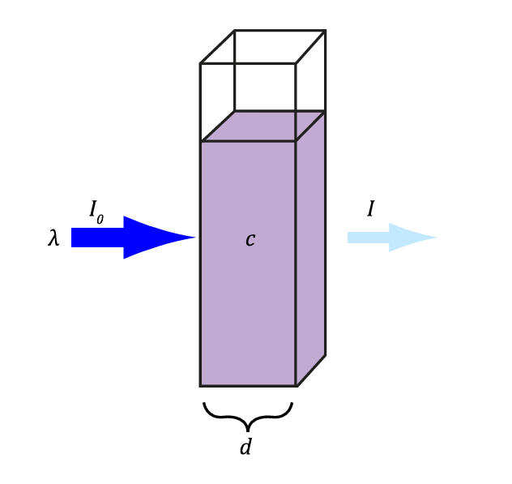
Fig. 1 Schematic of an absorption experiment

Inserting formula (2) in (1) leads to formula (3).

ΔA(λ, τ) = − log$\left(\frac{{I(λ,τ)}_{with pump}}{I_{0}(λ)}\right)$ + log$\left(\frac{{I(λ,τ)}_{without pump}}{I_{0}(λ)}\right)$
= log(I₀(λ)) – log(I(λ,τ)_{with pump}) − log(I₀(λ)) + log(I(λ,τ
)_{with pump})
= − log$\left(\frac{{I(λ,τ)}_{with pump}}{{I(λ)}_{without pump}}\right)$ ---(3)

Since the probing is done with a fixed laser wavelength, the formula reduces to
ΔA(λ, τ) = − log$\left(\frac{{I(τ)}_{with pump}}{I_{without pump}}\right)$ ---(4)

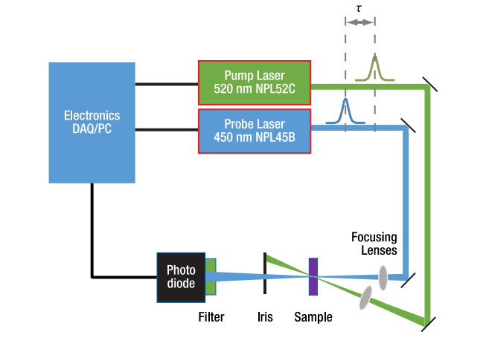
Fig. 2 Schematic representation of the time-resolved absorption setup

Transient Absorption Process

The transient absorbance ∆𝐴 has several contributing and competing processes, which are schematically depicted in Figure 3.

- Stimulated Emission (SE): The probing photon can interact with an excited molecule and lead to a stimulated relaxation back into the electronic ground state. This leads to the stimulated emission of a photon in the same direction and more detected photons in the probe beam, leading to a negative TA signal contribution.

- Ground-State-Bleaching (GSB): After excitation with the pump laser pulse, fewer molecules are in the ground state, so the probability for further excitations from the ground state is decreased resulting in a negative TA signal contribution.

- Excited State Absorption (ESA): Excited electrons can be further excited in higher states resulting in an absorption of the probe beam and a positive TA signal.

- Photoproduct Absorption (PA): The excited molecule can react, and a photoproduct is formed. The probe beam can be absorbed by the new photoproduct, resulting in a positive TA signal contribution.

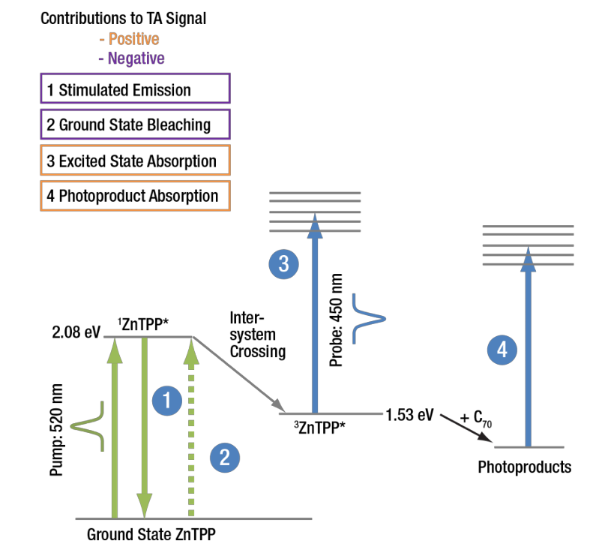
Fig. 3 Energy (Jablonski) diagram of possible excitation and deactivation paths in the transient absorption process. Processes can have positive or negative contributions to the measured TA signal. Process 1 and 2 (purple) reduce the TA signal whereas process 3 and 4 increase the TA signal.

In our experiment, which has a 450 nm probing frequency and the pump is a laser of 520 nm wavelength, for the sample ZnTPP, the dominating processes are ESA and PA since the overall TA signal is strongly positive. GSB can have some influence, but it is dominated by the other two processes.

In the first step the pump laser excites the sample into a triplet state. Typically, the rate of decay of a chromophore’s triplet can be described as:

---(5)
C_{T}(𝑡) is the concentration of the sample in the excited triplet state at a given time 𝑡. 𝐶_{G}(𝑡) is the concentration of sample in the ground state, and the corresponding reaction rates are denoted 𝑘_{𝑖}. The first term 𝑘₁ ⋅ 𝐶_{𝑇}(𝑡) describes the relaxation back to the ground state and is the main mechanism of the excited sample returning to the ground state (deactivation). The other two terms are bimolecular deactivation mechanisms where either an excited metastable state 𝐶_{𝑇}(𝑡) or the ground state 𝐶_{𝐺}(𝑡) takes part in the deactivation. In typical experiments, the concentration of excited is much lower than the ground state concentration, so the term (𝐶_{𝑇}(𝑡))² ≪ 𝐶_{𝑇}(𝑡)∙ 𝐶_{𝐺}(𝑡) is neglected for the following calculations. The third term 𝑘₃ ⋅𝐶𝑇(𝑡)⋅ 𝐶_{𝐺}(𝑡) describes the deactivation of the excited sample by molecules of the sample in the ground state. An additional assumption is that 𝐶_{𝐺}(𝑡) is not changed significantly by the excitation process (as comparatively few molecules are excited from the ground state) so that it becomes independent from time t, thus C_{G}(𝑡) equals C_{G}. This reduces formula
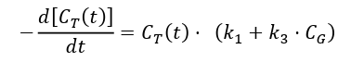 ---(6)

The remaining reaction constants can be summarized to one term: 𝑘_{𝑜} = 𝑘₁ +𝑘₃ ⋅𝐶_{𝐺}, simplifying the differential equation further to a first order integrated rate law:
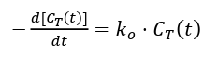 ---(7)
This type of differential equation is solved by an exponential function:
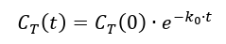 ---(8)
This solution describes an exponential decay of the triplet state with a decay time τ = 1/𝑘₀.
Additional reactants can open new deactivation channels. This process is often referred to as quenching and includes a variety of processes (e.g. photoinduced electron transfer as described in the next section). Thus, a new term is added to the rate of decay shown in
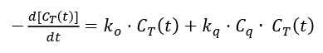 ---(9)
The reaction constant 𝑘_{𝑞} and the concentration of quenching material 𝐶_{𝑞} are denoted respectively. Again, the reaction parameters can be summarized to a single term, which is called the apparent reaction constant:
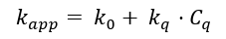 ---(10)
The solution of the differential equation now :
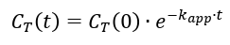 ---(11)
Again, an exponential decay is described, and this time with a decay time 𝑇_{𝑎𝑝𝑝} = 1/𝑘_{𝑎𝑝𝑝} .

The main goal of the transient absorption measurement is to examine how fast the excited triplet state ³ZnTPP* state is depopulated after being populated by a pump laser pulse. This is done via an absorption measurement with a probe laser of a wavelength that is strongly absorbed by the ³ZnTPP* triplet state (here: 450 nm). A photodetector measures the intensity of the probe laser after passing through the sample, and the absorbance of the sample can be determined from the detector voltages. This measurement is repeated for different delays between the pump and probe pulses, which will determine the speed with which the ³ZnTPP* state is depopulated. The experiment is schematically shown in Figure 3. The ³ZnTPP* concentration will be highest directly after the pump pulse hits the sample, and, as a result, the sample will absorb more of the probe laser pulse, resulting in a lower measured intensity behind the sample. Then, the excited state will decay over the span of several hundred nanoseconds, with the absorbance of the sample decreasing and the measured intensity increasing correspondingly. As the decay of ³ZnTPP* is in the order of nanoseconds to microseconds, it is very difficult to measure this time dependence in one cycle. Data points would have to be recorded with a frequency of several 100 MHz to achieve sufficient resolution. Instead, the ZnTPP is repeatedly excited and a time series of transient absorption values is measured with a gradually shifting delay between the two pulses.
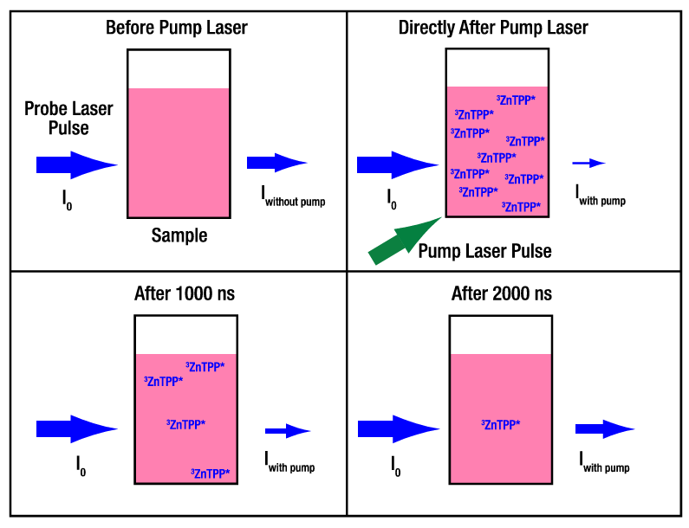
Fig. 4 The blue arrows indicate the probe laser pulse train energy before (I₀) and after
passing the sample (I_{with pump}). The thickness of the arrow correlates to the total energy /
amount of photons. The ³ZnTPP* concentration is highest directly after the pump laser
absorption and decreases when time has passed. In turn, the intensity of the probe laser
pulse train after passing the sample is higher with a lower 3ZnTPP* concentration.

Experimental Setup :
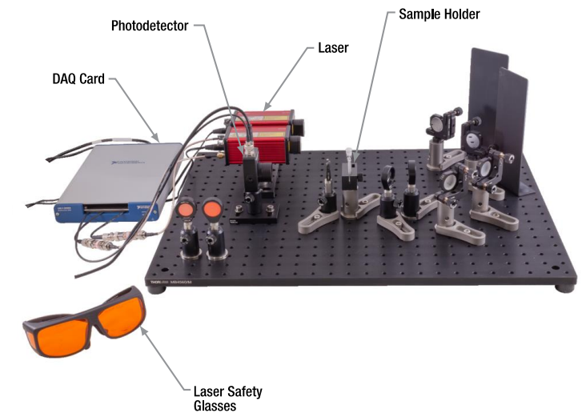
Fig. 4 Experimental setup

Sample Information : 5,10,15,20-Tetraphenyl-21H,23H-porphine zinc (meso-Tetraphenylporphine, TPP, Zinc TPP).
Molecular wt : 678.11
Conc : 0.5 mMol/L dissoved in Toluene (1.7 mg dissolved in 5 mL solvent).

Procedure : After ensuring the overlap of the pump and probe beams inside the sample volume, you should start the software Thorlabs-TA Experiment.
- Turn the keys of the lasers and wait till the LEDs on their backside stop blinking.
- Turn on the lasers by clicking the checkbox “Laser ON”.
- You can now measure the decay time of the excited state as follows :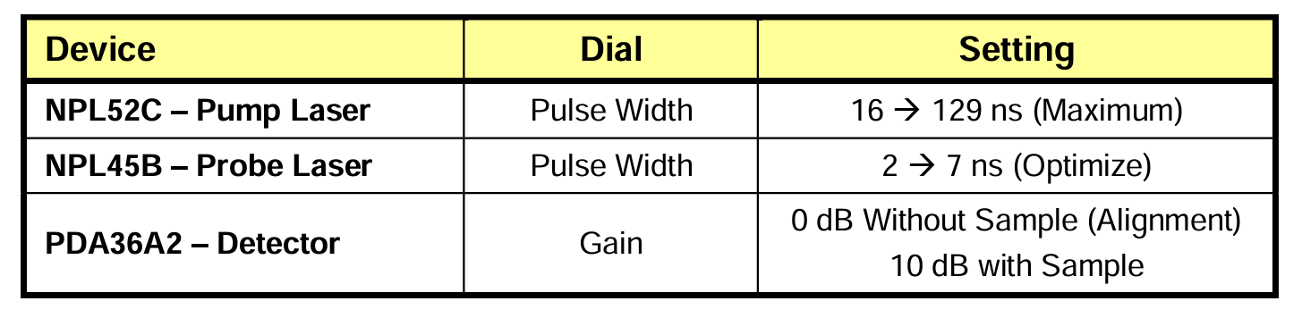
- Delay time between pump and probe signals must be set to 200 ns and the peak finder threshold must be set to about 0.2 V lesser than the pulse signals displayed in the detector signal live feed.
- Make the Baseline Correction checkbox is activated and Reduced Pump Frequency (10%) checkbox is deactivated. Then, switch to the Measurement Tab.
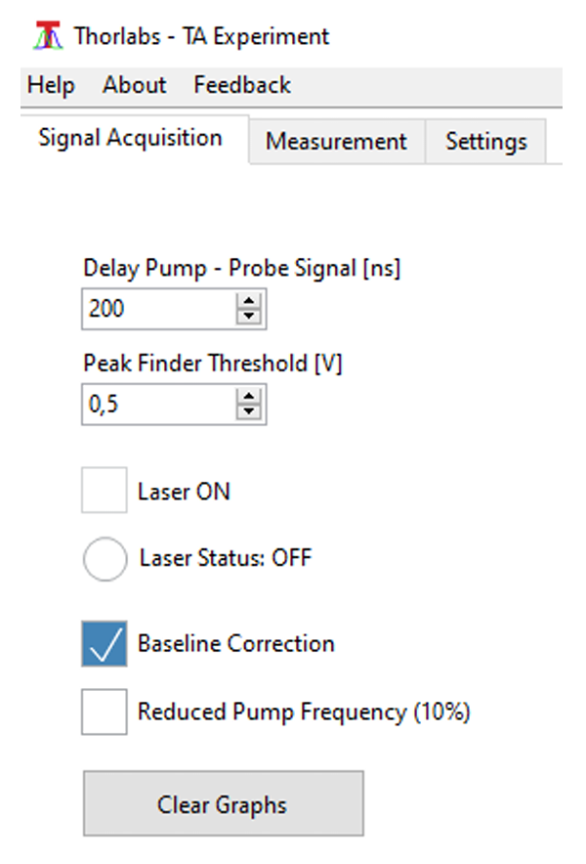
Fig. 5 Typical Settings Before Switching to Measurement Tab

- Set the lower and upper delay boundaries. We recommend a range of -400 ns to 5000 ns.
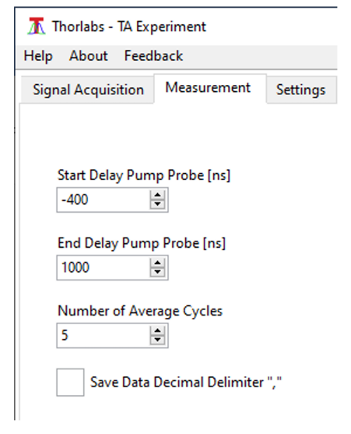
- Set the Averaging. We recommend a value of 5 for a good balance between noise and measurement time. A measurement with the recommended parameters, as shown in Figure 6, will take about 10 minutes to complete.
Fig. 6 Recommended Settings for Time Resolved Absorption Measurements

- Start the measurement. You will be prompted to select a name and path for the result file.
- Once the measurement is started, the software displays the following information :
- The measurement cycle you are currently in and the current delay between pump and probe cycle.
- All measured curves of this measurement (thin lines in various colours) and the average of all measured curves of the measurement (broad blue line).

- The curves should show a sharp rise of the TA signal at a delay between 0 and 150 ns followed by an exponential decay as shown in Fig. 7 and Fig. 8.
- After the measurement is finished, the results are saved in a .csv file in the path specified at the start of the measurement. The averaged curve is saved as well as all single traces in a separate “_traces.csv”. Additionally, a “.xml” file is saved with measurement parameters and the editable info box during the measurement.

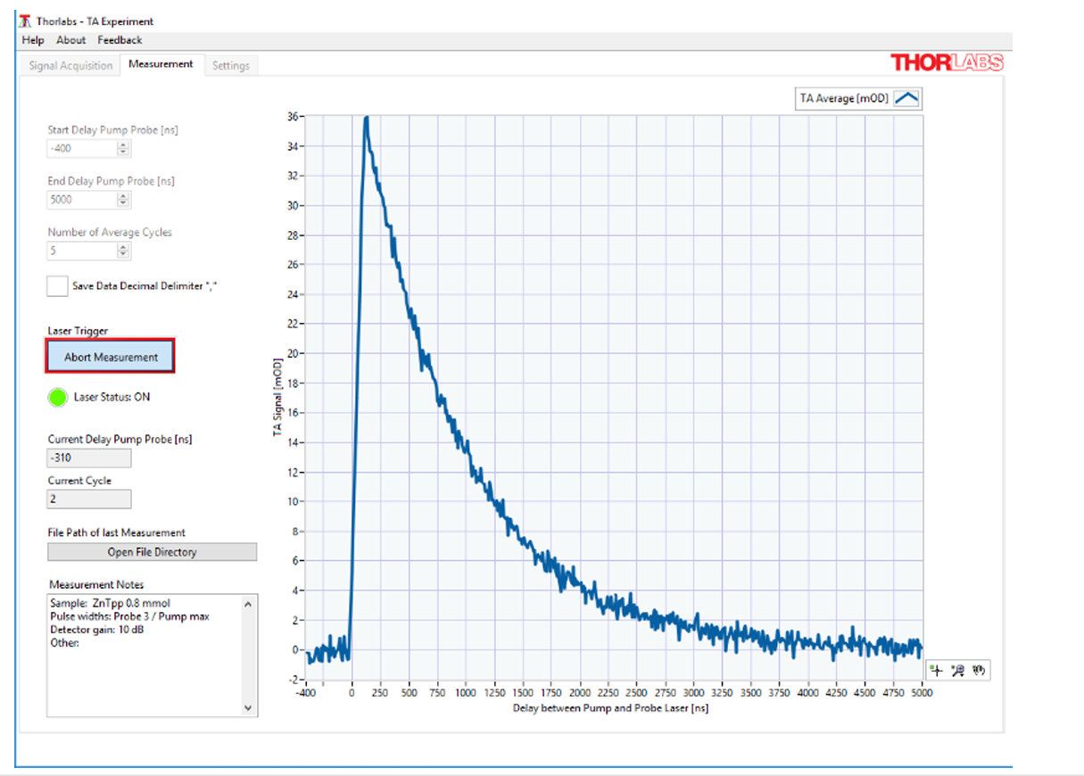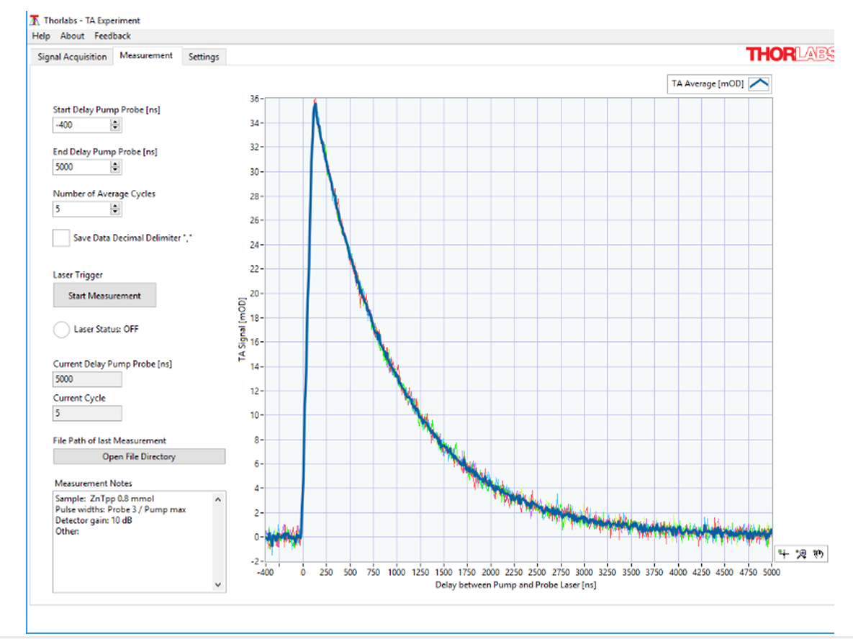
Fig. 7 Fig. 8
Screenshots During a Measurement
- Fit the decay curve obtained to an exponential decay fit and find out the relaxation time.
- Find out the relaxation time for three different pump pulse width (max, min and in between) and compare the three different results. State the reason behind this change that’s occurring.
- Another study that can be done is by changing the concentration of the sample to study the change in relaxation times. (NOT REQUIRED IN CLASS)
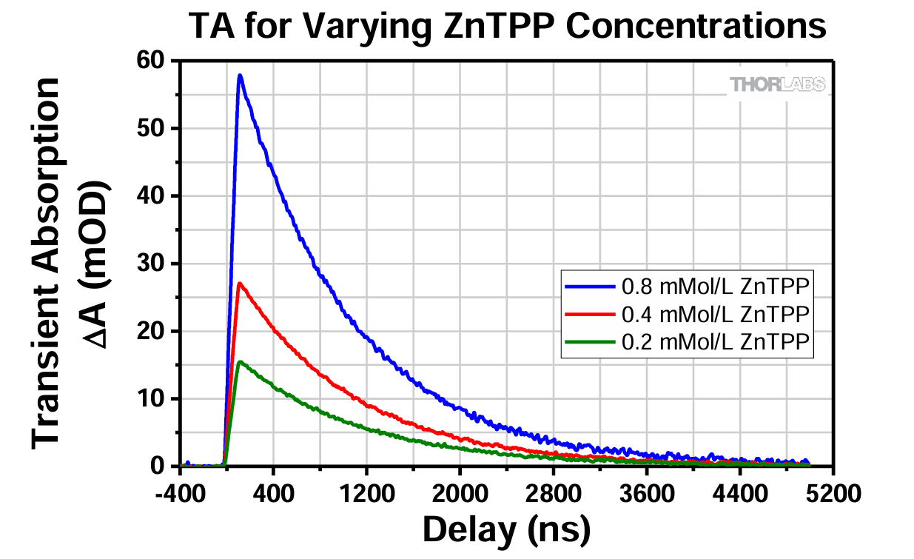
Fig. 9 Plotted Results of an Example Measurement for Three Different Concentrations of ZnTPP

WARNING : DO NOT tamper with the alignment of the setup at any cost. If there is a loss in signal, contact the TA. For more information visit the link : https://www.thorlabs.com/_sd.cfm?fileName=MTN026204-D02.pdf&partNumber=EDU-TRAS1/M

